

EVOLUTIONARY COMPUTATION FINAL PROJECT

OZAN CAN CELBİŞ

160709002

Description

Aim to this Project is looking to find the parameters (weights) that maximize such equation. Actually this is simple but the idea i am looking to implement is how to make GA do that its own in order to know that it is better to use positive weight with positive inputs and negative weights with negative inputs.

Firstly i created an equation has 6 inputs and 6 weights. And i defined to the initial population has 6 genes. And i created some functions for implement genetic algorithm (crossing-over , mutation , fittness of population and select the mating pool) for 5 generations . And the random changes moved towards a better solution.

Expected Outputs

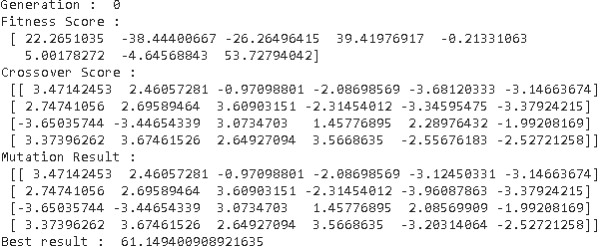

This is first generations scores and best result.

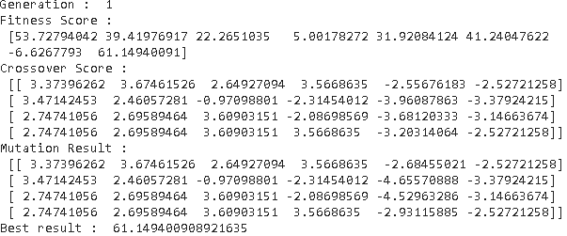

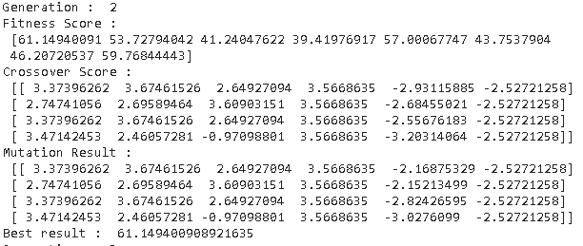This is second generations scores and best result.

This is third generations scores and best result.

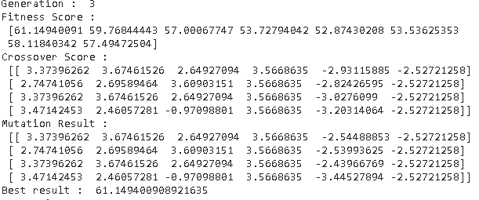

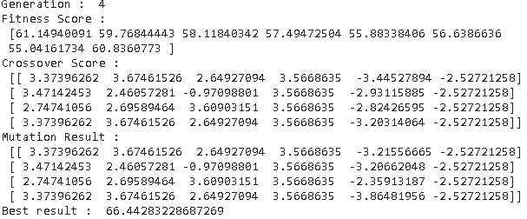This is fourth generations scores and best result.

This is fifth generations scores and best result.

This output is best solution and best solution of fitness.

Result

I actually learned a lot in this course. I understood how to learn some difficult-to-sound and even difficult algorithms and where I can use these algorithms in real life.